Week 4 — The Sign-Up Form & Bad Input

Objective:
The purpose of this test is to check whether a low-privilege account can create a new account with an admin role by changing the role field in the registration request using the /api/users/auth/register endpoint.

Result:
Test | Result | status
End user tries to create Admin | 403 Access denied | PASS
Analyst tries to create Admin | 403 Access denied | PASS
Ingestion Service tries to create Admin | 403 Access denied | PASS
Admin tries to create Admin | 201 Created | Allowed
Fake user_id added to request | Server generated its own ID | PASS

Test process:
The /api/users/auth/register endpoint was tested using the four user roles in the Phoenix project backend. I created 3 accounts for end users, analysts, and ingestion services. Then, I logged in as an end user and used the access token and tried to create a new account with the role as admin. The server returned a 403 forbidden with the message “Access denied,” which shows that the end user was not allowed to create an admin account.
The same process was repeated for analysts and ingestion services accounts, and the same outcomes happened. Both roles received a 403 forbidden, which shows that they were also not allowed to create an admin account.
However, when I used an admin access token and tried to create another account with the role set as admin, the server returned 201 Created and successfully created the new admin account. This shows that the admin role is allowed to create another admin account by setting the role in the request body.
In addition, I tested whether the user_id field could be controlled when creating an account. I added a fake user_id value when creating an ingestion service account. The server ignored the value I entered and automatically generated a different user ID for the new account. This shows the user_id cannot be manually controlled by the client.

Test process screenshots:

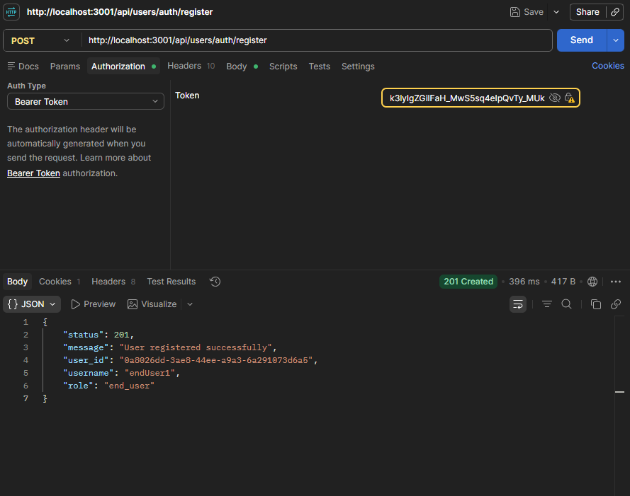
Figure 1: creating an end user account.

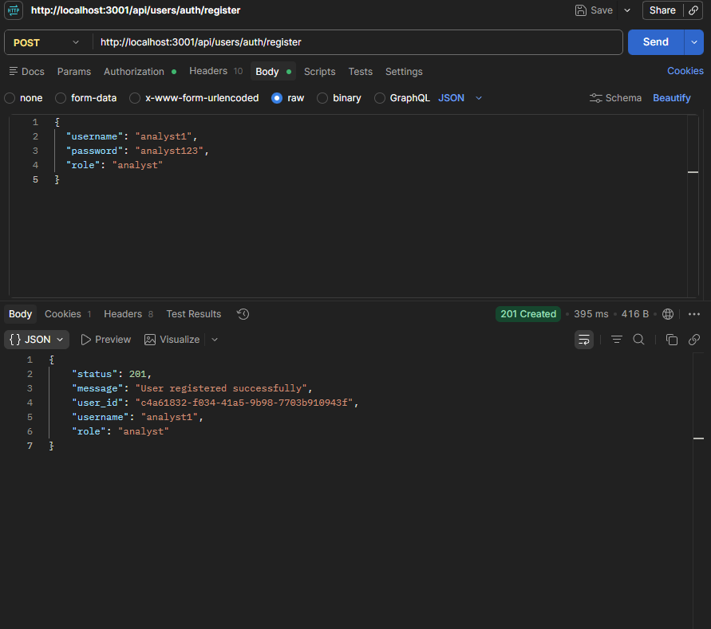
Figure 2: Creating an analyst account

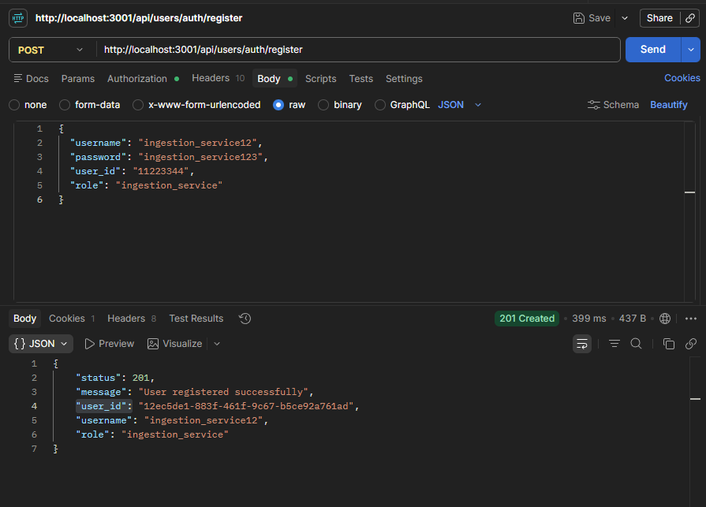
Figure 3: Creating an ingestion service account with a fake user_id

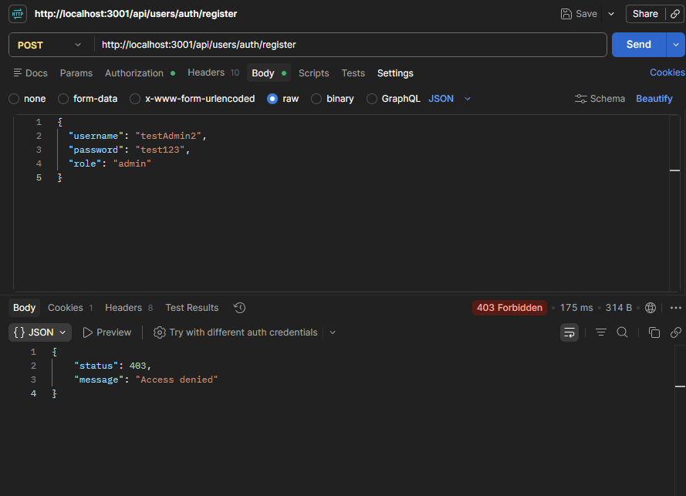
Figure 4: Access is denied for creating a new user with admin privileges using an end-user token.

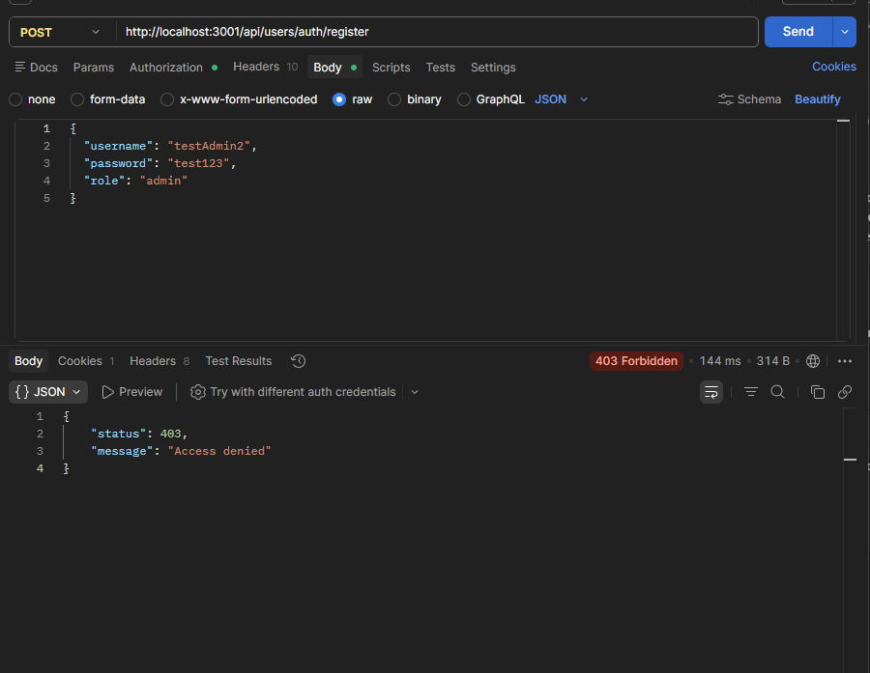
Figure 5: Access is denied for creating a new user with admin privileges using an analyst access token.

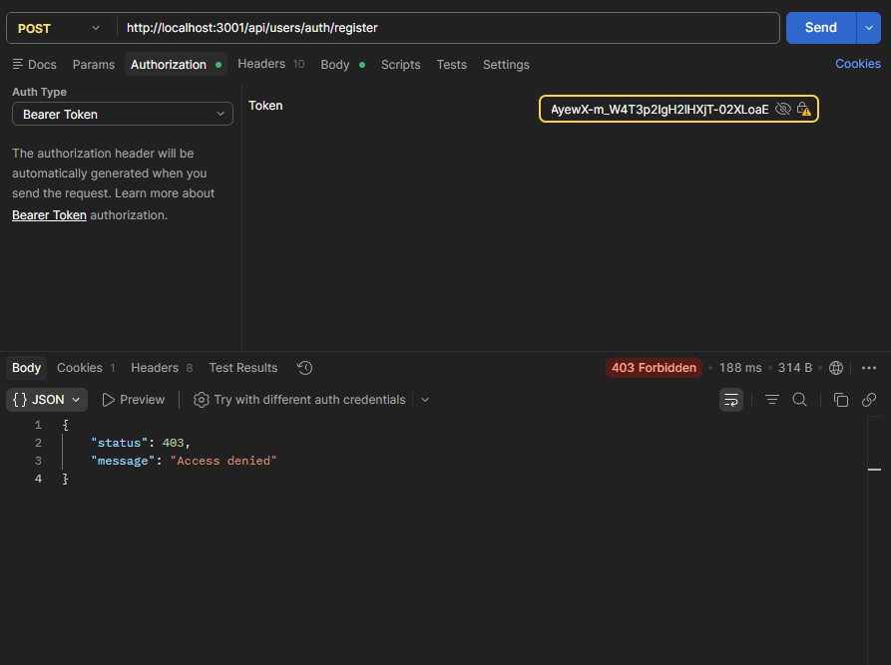
Figure 6: Access is denied for creating a new user with admin privileges using an ingestion service access token.

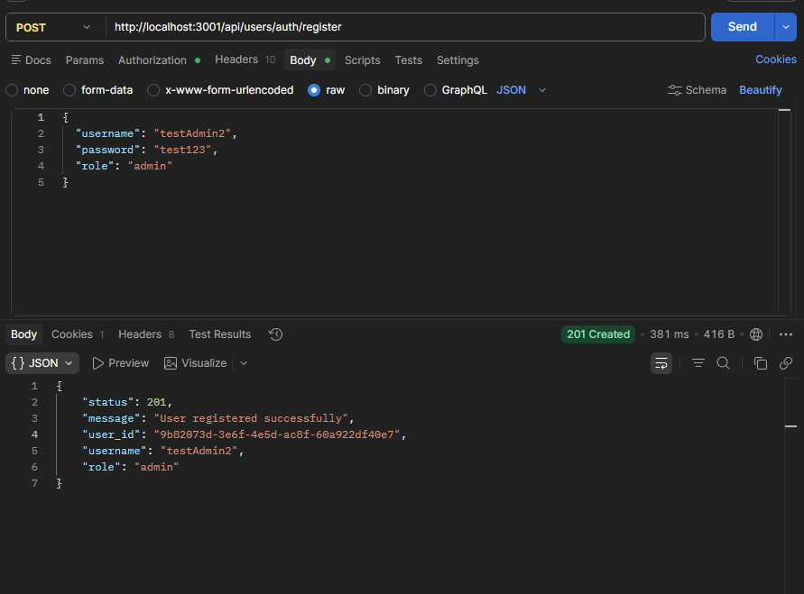
Figure 7: A new user with admin privileges was successfully created using an admin access token.

